Link to job listing: <https://www.glassdoor.com/job-listing/web-developer-multiply-JV_IC1131270_KO0,13_KE14,22.htm?jl=2523938938&ctt=1512446392399>

Link to Vue.js Documentation Source: <https://vuejs.org/v2/guide/transitions.html>

Link to GitHub Repository: <https://github.com/weixianlow/CS4830_Exploration4_Fall2017>

Link to Instance: <http://cs4830.weixianlow.me/exploration4>

Journal:

**Installation:**

To install the Vue.js framework, it’s as simple with adding a script tag containing Vue.js’ CDN into the html page you would like Vue.js to be enabled on.

**Setting up:**

To use Vue.js, you would be required to create an instance where it’s tied to a div element on the html page. You can do so by adding an id tag to the element you want the vue.js instance tied to: 

After tying the div element to the vue.js instance, you would then need to create a new instance using the following format:

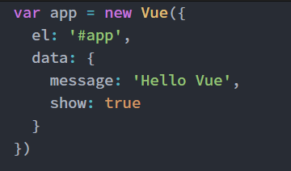

By doing that, the element would have given Vue.js access on the DOM. Since Vue.js is a reactive framework, it will work as similar as AngularJS.

**Areas Explored (Animations and Transitions):**

There are a couple of animation/transition I have explored on this exploration, as you could see with the link to my instance, all three would have different type of animation/transition tied to a button event.

To begin setting up in this demo the following CSS code is used.

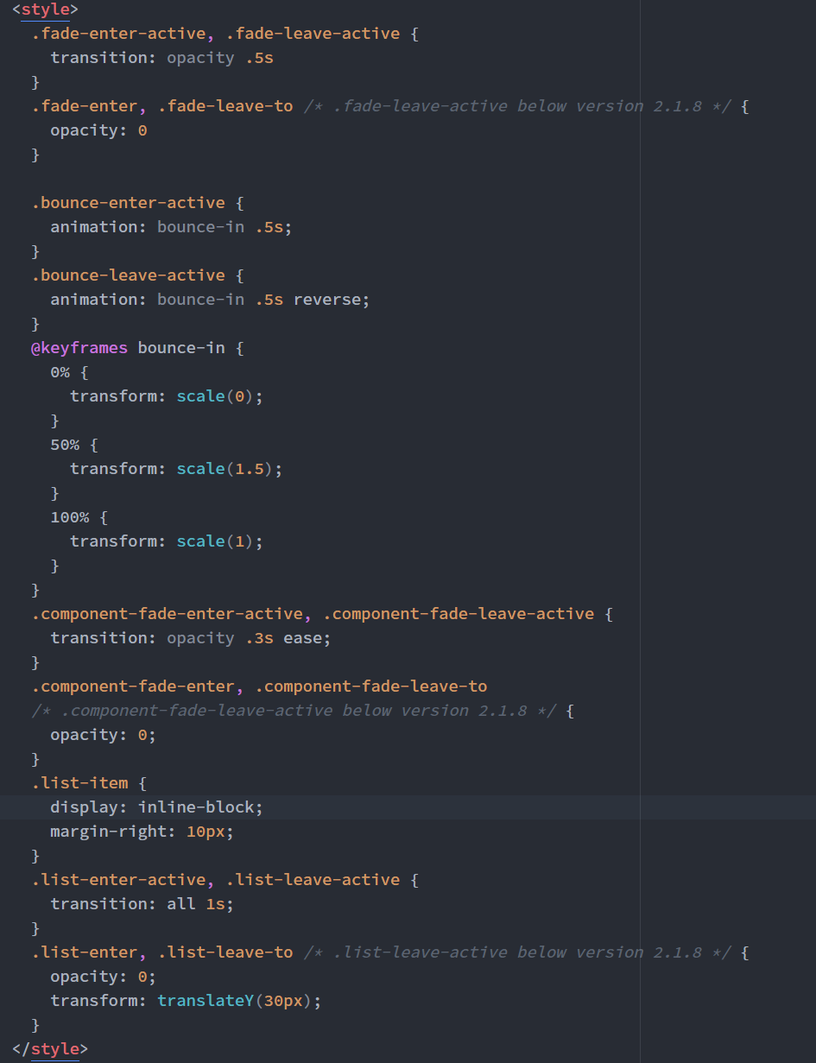

After creating the necessary CSS codes, we will then dive into the html and js code for the examples:

1. Example 1
   1. In this example, this is the code needed to handle a fade in and out button toggle.
   2. 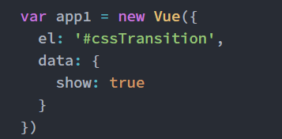
   3. 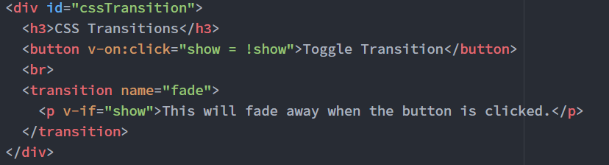
   4. In this code, the button will basically trigger a change of value in the Vue instance code, by changing show from true to its opposite value.
2. Example 2
   1. In this example this is the code needed to handle a specific fade in and out animation.
   2. 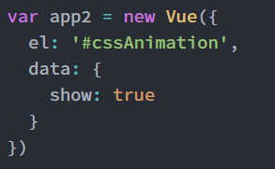
   3. 
   4. In this code, the button will perform exactly the same as the previous example, but the only difference is that the transition has a specific class type, which is bounce.
3. Example 3
   1. In this example, this is the code needed to handle an edit to a list on the DOM by adding In some animation.
   2. 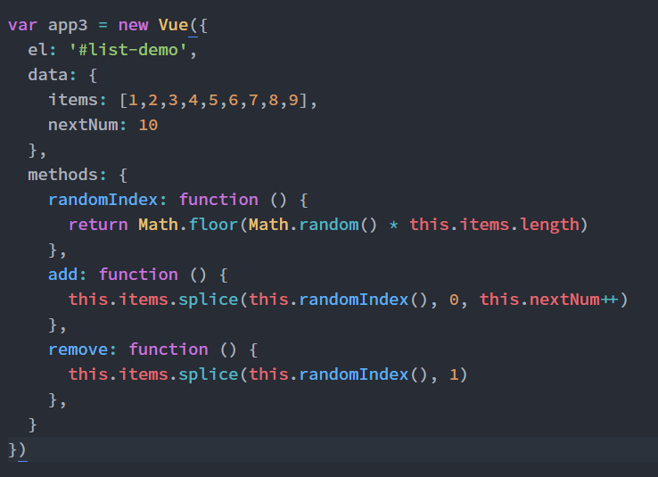
   3. 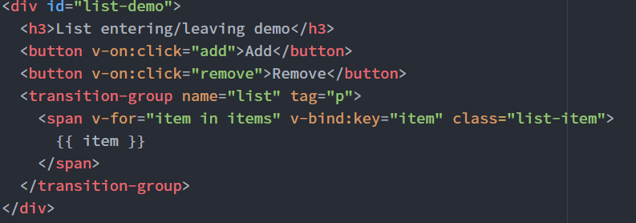
   4. In this code, the list is added and removed using the CSS code listed above and also the methods in the Javascript code so that random numbers can be added in.